Task Management System

Assume Antra has a client, which needs an application to manage its day to day tasks. Application must be developed with technologies Angular, .Net Core Web API, Entity Framework Core, SQL Server Database. Clients needs the following operations in the application.

# Tasks: -

Should be able to Add/Update/Delete/List the tasks.

# Users: -

Should be able to Add/Update/Delete/List the users.

# Task_History:-

Should be able to Add/Update/Delete/List the Task_history

Below is the database design for the application. All primary keys should be automatically incremented value.

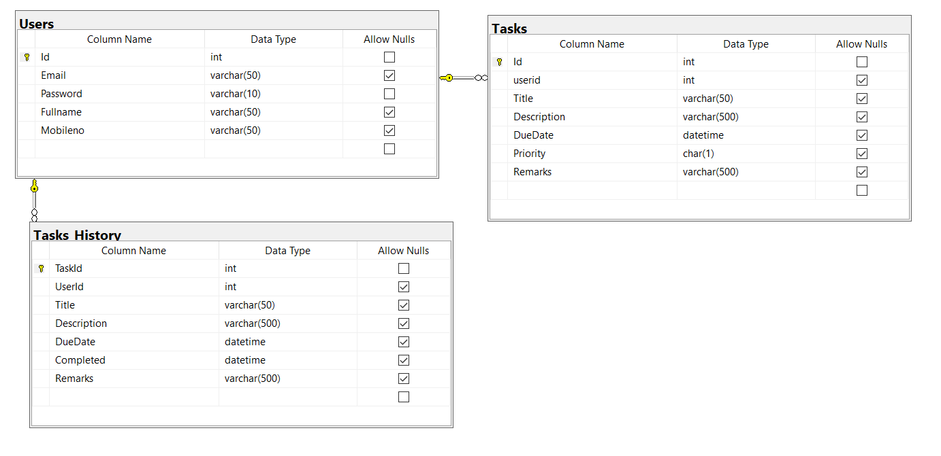

Guidelines:

1. Design the UI in Angular (Bootstrap 4 and ngBootstrap) home page should display Dashboard of Users and Username should clickable that should show all the Tasks that are completed and not completed. Once a Task a assigned toa user when he finishes that task it will go to Task History table. Whenever a Task is created it must be assigned to the User
2. Create Database with EF Core Code First approach using migrations.
3. Connect with the database using Entity Framework Core. (Use Best practices architecting your application)
4. Should use Dependency Injection
5. Write the business logic in services using ASP.Net Web API Core.
6. Test the API with Postman

# Deadline of the assignment

Finish your assignment in a day. Upload your code in Github with database script and share the link.